Alert Title/ subject: | UNACCEPTABLE DAMAGE TO PSTASS ASSEMBLIES
ALERT REF NO: | 2016alrt12 – 2/11/2016
REASON FOR ALERT: | Severe damage hAS BEEN caused to PSTASS assemblies Due to incorrect handling both on & offshore. Excessive & unacceptable damage has resultED in pstass (EBS) failure.
Description: |  |  | Insert Photograph:
A recent incident occurred where the non-availability of serviceable PSTASS EBS units offshore led to a passenger having to be removed from a return flight. The EBS units in question after investigation were found to have sustained impact damage that ultimately led to a release of compressed breathing air.  The impact damage found is relevant to the PSTASS units being dropped, thrown down or knocked against a hard surface.  The photos to the right show the excessive damage seen on a daily basis.  Photos 1 & 2 –  Photo 3 – Ratchet knob showing signs of impact damage & heavy wear & tear. Label to assist safe operation scraped & torn. |  |  | 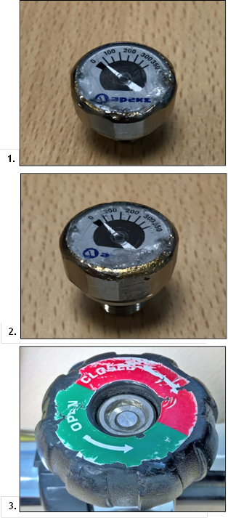
Description: |  | Insert Photograph:
Photo 4 - Charging port cover dented & part broken off as a result of impact.  Photo 5 - Head of PSTASS showing dents & gouges caused by heavy impact.  Photo 6 - Internal pin which has bent due to the force of impact. |  | 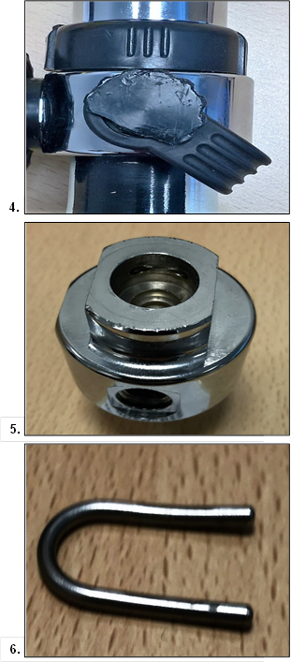
Description: |  | Insert Photograph:
Photo 7 - Internal connector showing wear cause by impact against hard surfaces.  In addition, heavy impact damage causing internal O-rings to unseat which have led to expulsion of air from the PSTASS cylinder. |  | 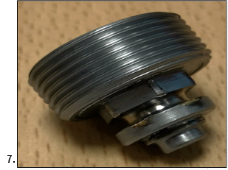
IMMEDIATE RECOMMENDATIONS:
Bulletin to be distributed to all heliports & customers/users of the MK50 lifejacket & PSTASS EBS. All passengers, ground and offshore handling personnel to be made aware that failure to handle potentially life-saving survival equipment with adequate care may cause the equipment to fail to function correctly.

ACTIONS TO PREVENT RECURRENCE:
Equipment damaged by handling or user misuse will be recorded and reported for discussion with the applicable customer and helicopter operator.

Proposed improvements to the MK50 lifejacket transportation bag – recommend the use of a padded bag with inner liners attached that can be placed between each lifejacket/PSTASS to provide additional protection during transportation. Survitec will support a revised holdall for review and proposed introduction as standard.

Prominent display of this alert at heliports & offshore installations. passengers & handling staff to be made aware of the importance of treating survival equipment with due care & attention

Survitec heliport staff to monitor & report all incidents of misuse & associated damage

Post for
30 days minimum

